Harmony Extensible Schema Matcher Version 1:
User Guide

The MITRE Corporation
August 7, 2009

Table of Contents

1. Introduction to Harmony 1
2. Installing and Running Harmony 2
2. Importing Schemas 4
3. Selecting Schemas 6
4. Saving and Opening a Mapping 8
5. Viewing Schemas 9
6. Searching Within a Schema 13
7. Manual Schema Element Matching 14
8. Automatic Schema Element Matching 15
9. Exporting Schema Element Match Information 19

Introduction to Harmony

Harmony is a tool designed to assist in the task of data integration, which is the process of merging data from different sources. For example, imagine the army has a database which includes a field called “target_loc” which stores the location of an enemy target as a latitude and longitude. The navy might have an XML schema with an entity that also represents the location of an enemy target, but it is called “EnemyLocation” and is stored using a different coordinate system. Without data integration, the two branches will not be able to use each other’s data or indeed may not even know that the other has the data in question.

If the army and navy got together ahead of time and carefully compared the army database schema to the navy’s XML schema, they could identify that “target_loc” and “EnemyLocation” represent the same kind of data, and of course they could find many other such matches.

Without a tool like Harmony, data integration is very time-consuming, especially if the data schemas are large. Data integration specialists often spend weeks poring over spreadsheets creating the mappings more or less “by hand.” Harmony is designed to make schema matching much easier and faster. Our experience with several large tasks has shown a dramatic reduction in the time (informally, around an 80% reduction) needed to create a complete mapping as compared to working with spreadsheets alone.

Terminology

Schema: A structured representation of a set of concepts and the relationships between them. Examples of schemas include database schemas, XML schemas, and OWL ontologies.

Element: The basic unit of data in a schema. Examples of elements include database fields, XML elements, and OWL elements.

Source and target: A source (schema) contains elements that are being “mapped-from” while a target (schema) contains those elements that are being “mapped-to”. In the GUI, sources will be on the left and targets on the right. Users specify which schema is to be the source and which schema is to be the target for any given mapping.

Link: A relationship between an element in a source schema to an element in a target schema.

Mapping - The set of all links between elements in a given schema-pair (source, target).

Graph Model – A view of the schema which ignores some relationships within the schema to produce a tree. (Schemas may be cyclical or disconnected, while Harmony is only capable of displaying trees. Therefore schemas are always displayed using graph models.)

The Components of Harmony

Harmony consists of several major components: a data repository including various tools for working with different kinds and formats of schemas, a graphical user interface, and several automatic schema matchers. It is also designed to be extensible. Developers may create their own schema importers, mapping exporters, and automatic matchers. Development of those extensions is, however, outside the scope of this User Guide.

Data Repository

Harmony uses an internal database (by default an open-source Apache Derby database) to store schemas (converted to a custom format known as M3), mappings, annotations, and relationships between schemas (for example extensions.) Various tools are provided for working with the data repository, so the user does not need to interact with it directly. Those tools will be explained throughout this document where relevant to the task at hand.

Automatic Matchers

Several automated schema matchers are included with Harmony. They use clues like the similarity of element names, the words in description fields, and the structure of the schemas to provide candidate mappings. While they are far from perfect, it is generally much faster for a user to begin with an automatic mapping and then modify it than to create the mapping from scratch. Included automatic matchers are described in Section X, Using the Automatic Matchers.

Graphical User Interface

The Graphical User Interface (GUI) provides a graphical representation of the schemas and the mappings between them as well as a central “command center” for all of the various tools associated with Harmony. The rest of this document will explain how to accomplish various tasks from within the GUI.

2. Installing and Running Harmony
Prerequisites
Java 5.0 or above, Windows XP and above.

Environment Variable
The environment variable “java” should be assigned to the full pathname of java.exe:
First, find the location of your java.exe file. If Java is installed in its default location, java.exe will be located in a directory like “C:\Program Files\Java\jdk1.6.0_01\bin.” Depending on your version, the numbers following “jdk” may vary. If you are having trouble finding java.exe, use the Windows search feature to find it by opening the Start menu and selecting “Search->For files and folders…”

Next, set the environment variable:
In the Windows Start menu, select Settings->Control Panel->System. Select the “Advanced” tab. Click the “Environment Variables” button.
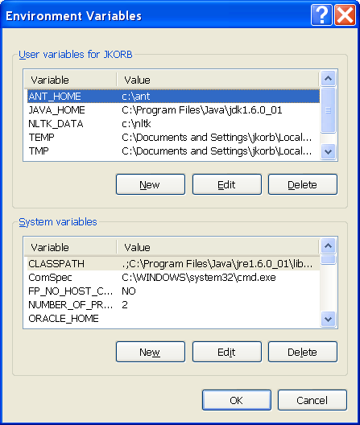

Under the “User Variables” box, click the “New” button. In the “Variable name” box, type “java” and in the “Variable value” box, type the directory of your java.exe, for example “C:\Program Files\Java\jdk1.6.0_01\bin.” Click “OK” to close that box, “OK” to close the “Environment Variables” box, and “OK” to close the “System Properties” box.
Installing Harmony
To install Harmony, unzip Harmony.zip into the folder of your choice. Then, Harmony is run by double-clicking on the Harmony.bat file.

2. Importing Schemas
The first step in creating a mapping between schemas is to identify the schemas to be used in the mapping. If all of the schemas to be used in the mapping already exist in Harmony’s data repository, proceed to Section 3, Selecting Schemas.

For each schema that does not yet exist within the repository, it is necessary to first import it. “Importing” a schema converts it from its native format (e.g. a file or database) into an internal format used by Harmony’s data repository. After importing it, the schema persists in the repository and may be selected for use at any time. (See Section 3, Selecting Schemas.)

To import a schema:

- Under the “Mapping” menu, select “New.”

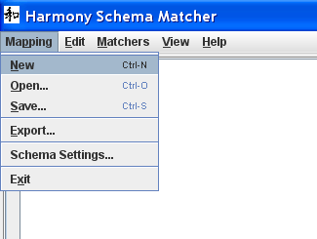

- The Mapping Properties Dialog box will be displayed:

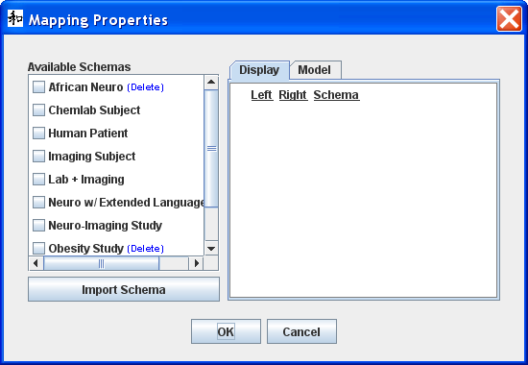

- To import a schema, click the “Import Schema” button. The Import Schema dialog will be displayed:

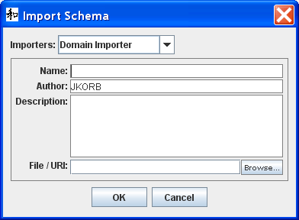

- Select the importer from the “Importers” drop-down box which corresponds to the format of the schema to be imported.
- Enter a name for the schema. This name will be the name displayed in the “Available Schemas” pane of the Mapping Properties box, so it should be unique and descriptive.
- Harmony auto-populates the “Author” field based on the Windows user account that started Harmony. If desired, it may be changed.
- Depending on the importer, a schema may be imported by selecting a file using a file open dialog or via a URI that points to, for example, an ODBC connection.
  - To use the file open dialog method, click the browse button to navigate to and select your schema file.
  - To use the URI method, type the URI into the File/URI box.
- Select “OK.”
- The schema should now be visible in the “Available Schemas” pane.

3. Selecting Schemas
- If the “Mapping Properties” dialog box is not open, open the “Mapping” menu and click “New.”

- Select the schemas to be mapped by checking the boxes to their left. (While it is most common to create a mapping between two schemas, Harmony supports mapping several source schemas to several target schemas.) As you check the boxes, the schemas will appear in the “Display” pane on the right:

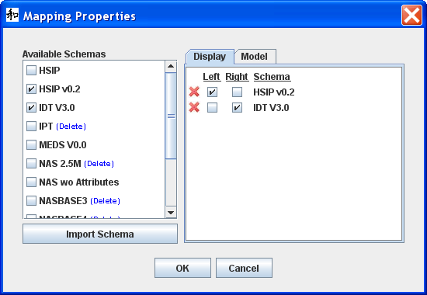

- Then select the box labeled “left” for the schema(s) you want to view on the left side of Harmony and “right” for those you want on the right. By convention, the “source” schemas go on the left and the “target” or “destination” schemas go on the right.
- A schema may be removed from the “Display Pane” and consequently from the mapping in two ways:
  - Click the red X to the schema’s left.
  - Uncheck the box to the left of the schema in the Available Schemas pane.
- To specify a Graph Model other than the default, click the “Model” tab and select the Model:
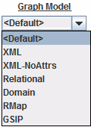

- Click “Ok.” The Mapping Properties dialog will be closed and the selected schemas will be visible in the main window.

4. Saving and Opening a Mapping
Harmony does not save changes automatically. To ensure that work is not lost, the user should save the mapping frequently. For a mapping to be saved, there must be schemas on both sides of Harmony, but no links are required.

- Under the Mapping menu, select “Save” to bring up the “Save Mapping As” dialog.

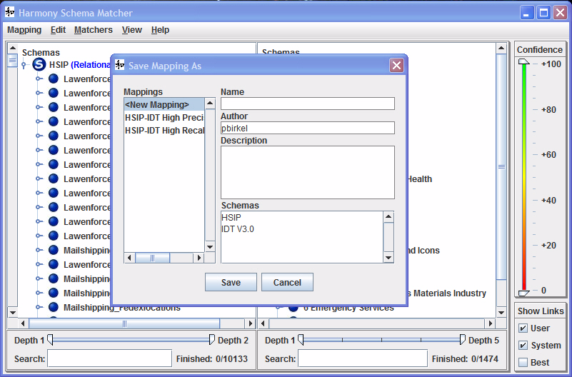

- To overwrite an existing mapping, select a mapping from the “Mappings” pane and select “Save.”
- To save as a new mapping (i.e. a mapping with a new name) select “New Mapping” from the “Mappings” pane, then enter a name and description and then select “Save.” The author field is auto-populated based on the Windows user account, but it can be edited.

After “Save” is selected, the Save dialog will close and the main window will be visible. The user may continue to work.

To open an existing mapping, select “Open” from the Mapping menu. Select the mapping from the Mappings pane and click OK. The main Harmony window will be displayed with the schemas and links visible.

5. Viewing Schemas
After schemas have been loaded, either by opening preexisting mappings (Section 4) or by selecting (Section 3) or importing (Section 2) schemas directly, they will be visible in the main Harmony window :

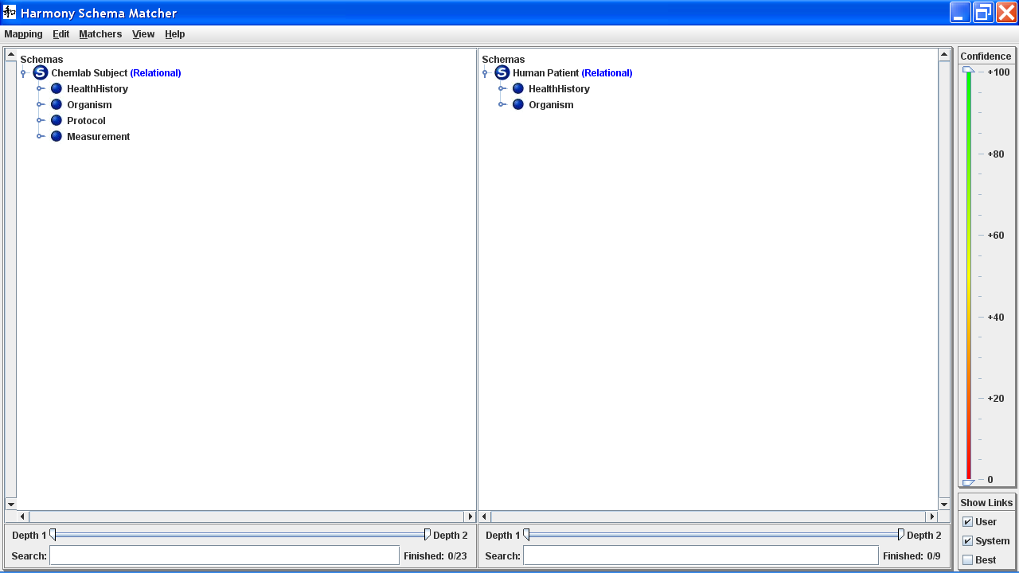

Under the word “Schemas” on each side, each schema is marked with a blue bubble with a white ‘S’ followed by the name of the schema. In parentheses is the name of the Graph Model being used to display that schema. You may change the Graph Model being used by clicking on it and selecting the desired Graph Model from the menu:

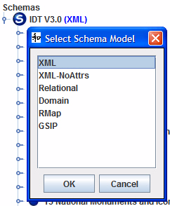

Schemas in Harmony are displayed as “trees.” Every row in either schema panes other than the word “Schemas” represents a “node” in that tree. A node may or may not have “child” nodes. To the left of the node is an icon representing the type of that node (ADD DETAIL.)

Trees are organized according to the Graph Model being used. (ADD DETAIL.)

If a node has child nodes, the following gray switch will be displayed to its left:

When it is horizontal, all child nodes (and their child nodes, etc.) will be hidden. To display the child nodes, click the switch. It will then appear vertical:

The node’s child nodes will also be display. This is what the “Chemlab Subject” schema from the above example looks like with the “Organism” node expanded:

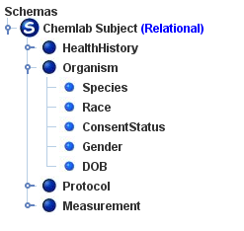

You may also right-click on any node for some more options:

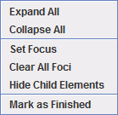

“Expand all” displays all of the node’s child nodes, and those child nodes’ child nodes, through all of the “descendants.” “Collapse all” hides all descendants.

“Set Focus,” “Clear All Foci,” and “Hide Child Elements” will be explained in Section 8, Using the Automatic Matchers.

“Mark as Finished” will be explained in Section 7, Working with Links.

[INSERT DISCUSSION OF TYPES]

You may also view more information about any element by left-clicking on it. A box will appear at the bottom of the window with the element’s name, description, type, attributes, and/or domain values where applicable:
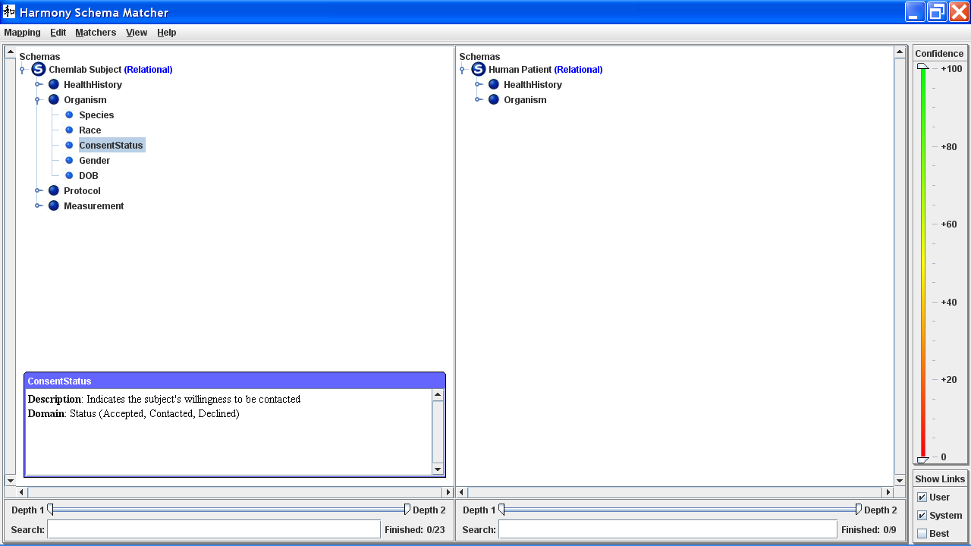
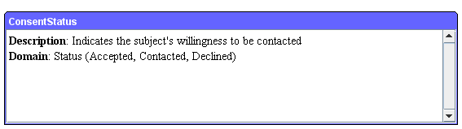
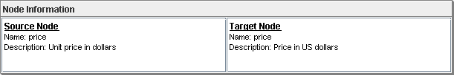
Figure 3.1 – Node Information Window

6. Searching Within a Schema
To search for keywords within names and descriptions of elements in a given schema, enter the substring into the “Search” field located below the applicable schema pane and then press “Enter.”

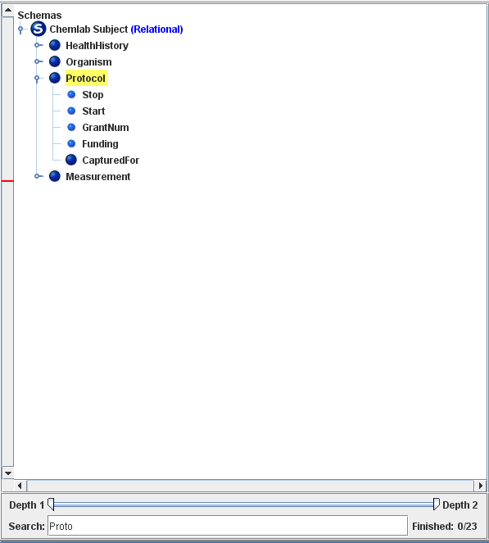

All schema elements containing that string of characters will be highlighted in yellow. On the applicable vertical scrollbar, one or more red lines will appear that indicate each of the locations of any matching schema elements which cannot be displayed without scrolling the schema graph display vertically. You may also use the asterisk wildcard in searches. For example, searching for “New*Time” would locate schema elements with the names “NewStartTime”, “NewStartingTime”, and “NewClosingTime”. Schema elements with descriptions containing these substrings would also be located.

Manual Schema Element Matching

To manually create a match link between two schema elements, select an element in one schema and drag to an element in the other schema. Harmony will display a black line between them. You may then select that match link by right-clicking on that line to bring up an annotation dialog:

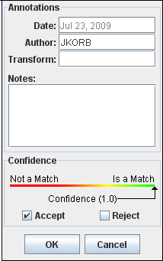

- Harmony provides two fields for annotation, labeled “Transform” and “Notes.” At present, they are both simple text fields.

- There is also a confidence score attached to each match link. If the match link was created by the user, the confidence score is always set to 1. If the match link was created by a software matcher, the confidence score may vary between 0 and 1, representing the degree of confidence of the matcher, with 1 representing 100% confidence. Note that the color of the link changes to reflect the confidence score.

- You may use the color-shaded (red to green) slider bar to the right of the Harmony screen to view only match links above and/or below a given confidence score threshold.

- You may use the “Show Links” box in the bottom right to display only match links generated by the user, those generated automatically, or only the match links with the highest confidence score connected to each node.

- Links to descendents of a non-expanded schema element will appear as dotted gray lines connected to that non-expanded schema element.

- Selecting “Accept” will set the confidence score to 1 and the match link color to black.

- Selecting “Reject” will delete the match link.

- Pressing the “delete” key will also delete the selected match link.

- You may “Accept” all match links connected to entity schema element by right-clicking on that schema element and selecting “Mark as Finished.” You can undo that by right-clicking and selected “Mark as Unfinished.”

- You may select or delete all Schema Mappings from the Edit menu.

Automatic Schema Element Matching

Introduction
As creating match links manually is very time-consuming, Harmony provides a number of automatic matchers which use clues like the similarity of entity names, the words in the description fields, and the structure of the schema graphs to suggest candidate links between schema elements. Match links are given a confidence score based on the matcher’s confidence that the link represents a genuine match. Information regarding a proposed match may be examined by right-clicking on the match link. Links are also color-coded by their confidence score.
Many real-world schemas are very large; a complete automatic matching between any given pair might take so long and use so much computer memory as to be impractical. Therefore, Harmony provides several ways of narrowing the mschema matching problem.

Harmony has been successfully used with schemas containing thousands of elements. A case study is described in:
Ken Smith, Peter Mork, Len Seligman, Arnon Rosenthal, Michael Morse, David M. Allen, and Maya Li, "The Role of Schema Matching in Large Enterprises", Conference on Innovative Database Research (CIDR '09), Jan 2009.

The Matchers
- Name Similarity. Compares names based on their similarity, using “edit distance,” a standard computational linguistic technique. As an example “control” and “cntrl” have an edit distance of 2 (two characters are deleted) so they would have a relatively high similarity score.
- Documentation Similarity. Compares the words found in the documentation as well as in the names without regard to order or syntax. For example, if on one side you have an entity with the name AC and a description that says “Airport Code,” and on the other side an entity called “Code, Airport,” this matcher would link them.
- Documentation + Synonyms. Like the Documentation Similarity matcher, except it uses a thesaurus (WordNet) to match synonymous words. For example, it would link “Airport” and “Aerodrome.”
- Exact Structure. ????

Narrowing the Match Space
There are several methods of choosing a subset of elements from each schema to match at once. If your schemas are large or if you want to divide your work, you’ll want to use one or more of these techniques before running the matchers.
- Setting the focus. This technique is especially useful for matching within a single schema subgraph at a time. Right-click on schema element and choose “Set Focus” to set the focus on that schema element and all of its descendents in the current schema graph.
You may set more than a single focus. To clear one focus, right-click on the schema element and choose “Clear Focus.” To clear all focuses, right-click and choose “Clear All Foci.”
- Setting the depth. This technique is especially useful if your schema graph is deep and you’re interested mostly in matching non-leaf schema elements. At the bottom of each schema pane is a depth slider. You may set the minimum and maximum depth. (Root nodes are at depth 1, their children at depth 2, etc.)

In this example, two subgraphs are in focus on the left schema while the right schema is set to depth 1:
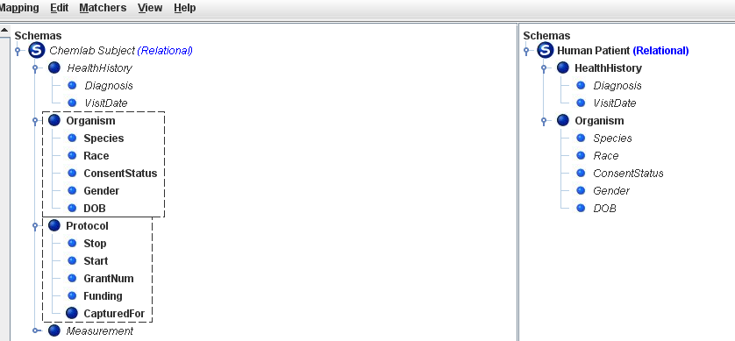

Note that schema elements falling outside of the focus or depth are grayed out and italicized.

Running the Schema Element Matchers
Once you have set the focus and/or depth appropriately (or if you have small schemas and are matching the complete schemas) you are ready to run the schema element matchers. Matchers may be run individually or in combination. When run in combination, the scores from all of the schema element matchers are combined using a mathematical formula by a “Vote Merger.”
- To run all matchers, select “Vote Merger” and then “Full Match” from the Matchers menu at the top. (Advanced: You may specify which element types in one schema – for example entities, attributes, or subtypes – to match to specific element types in the second schema by selecting the “Typed Vote Merger instead.”)
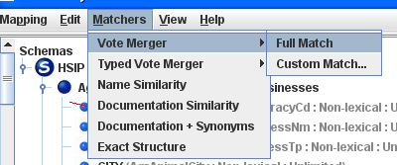
- To run an individual matcher, select that matcher from the Matchers menu.
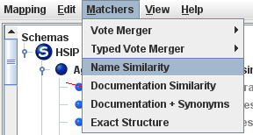
- To run several but not all matchers, select “Vote Merger” (or “Typed Vote Merger”) and then “Custom” from the Matchers menu.
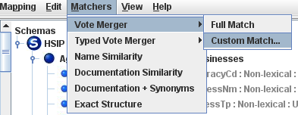
You will see a dialog box allowing you to select which matchers (also known as “match voters”) to run, as follows:
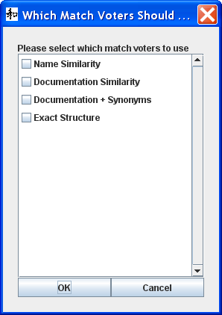

After you run the schema element matcher(s), you should see some multicolored links like this:
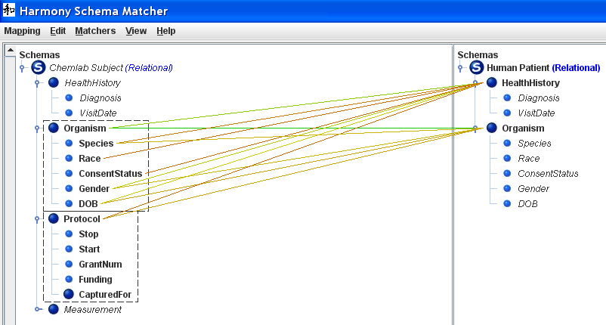

See also section 7, Manual Schema Element Matching for more information.

Exporting Schema Element Match Information
It is often useful to export schema element match information for use in other tools. For that reason, Harmony includes several mapping exporters.

To export a mapping, select “Export” from the Mapping menu:
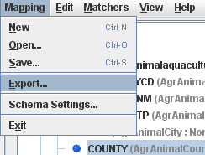

The Export Dialog will be displayed:
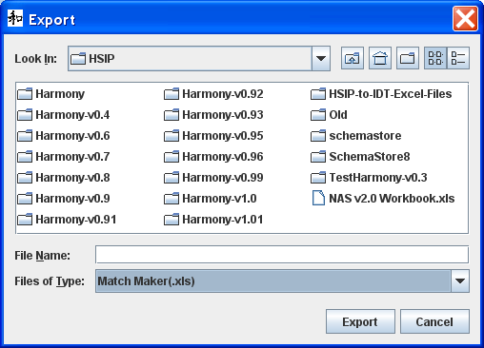
Navigate to a directory in which the exported file is to be saved by clicking the arrow in the row that begins with “Look In:”
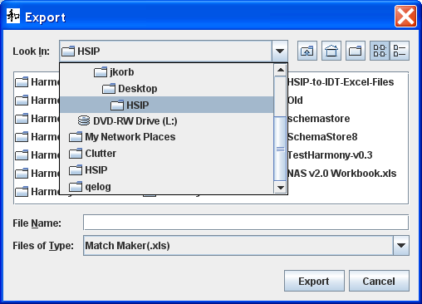
Select an exporter by clicking the arrow at the end of the row that starts with “Files of Type and then selecting an exporter:”
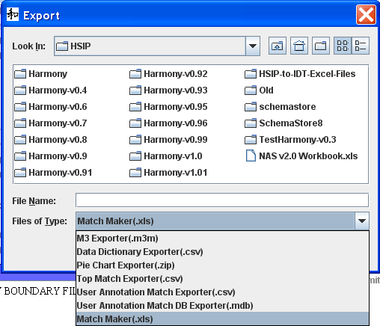
Then enter a new file name or select an existing file to be overwritten and click “Export.” [BUG HERE – HARMONY APPEARS TO FREEZE WHILE EXPORT RUNS] The file will be created and the Export dialog will close. The main Harmony window will be visible and the user can continue working.
- Importing Schema Element Match Info.
At present, importing schema element match information can only be done from within a separate tool called OpenII.
To import a mapping, run OpenII by [INSERT DETAIL]
[INSERT REPOSITORY DETAIL]
Right-click on “Mappings” within the Manager pane and select “Import Mapping”
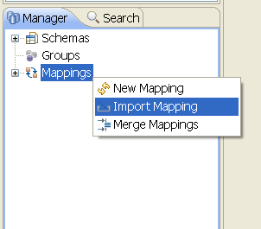

The Import Mapping dialog will be displayed:

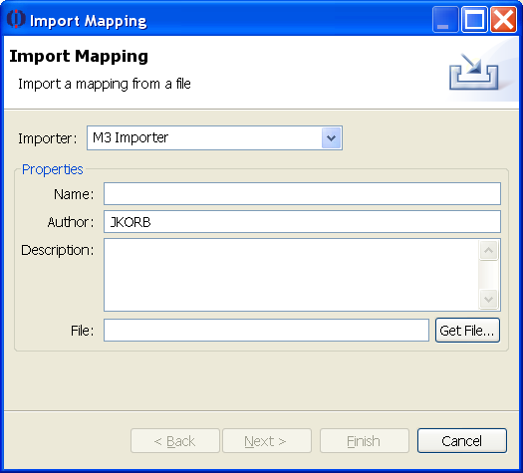

To select an importer, click the arrow at the end of the line that begins “Importer:” and select the desired importer:
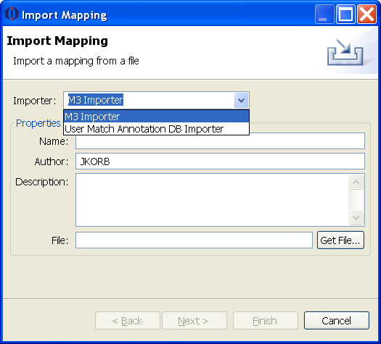
In the name field, enter a name which will be used to identify the mapping in the future. Enter a description of the mapping in the Description field.
Click the “Get File…” button to open the Import Mapping file dialog:
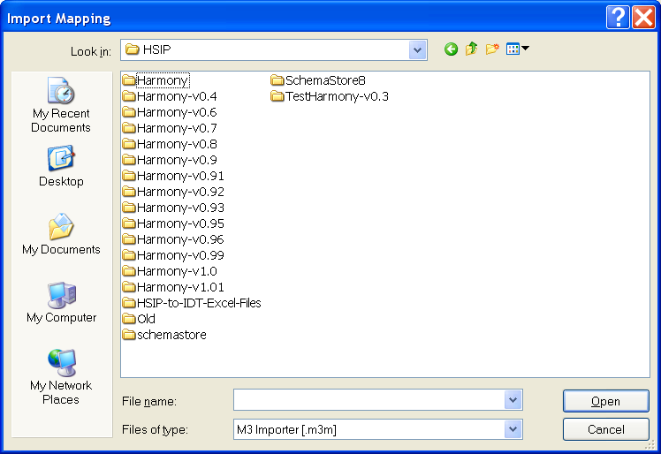
Click the arrow at the end of the line starting with “Files of type” to and select the appropriate importer:
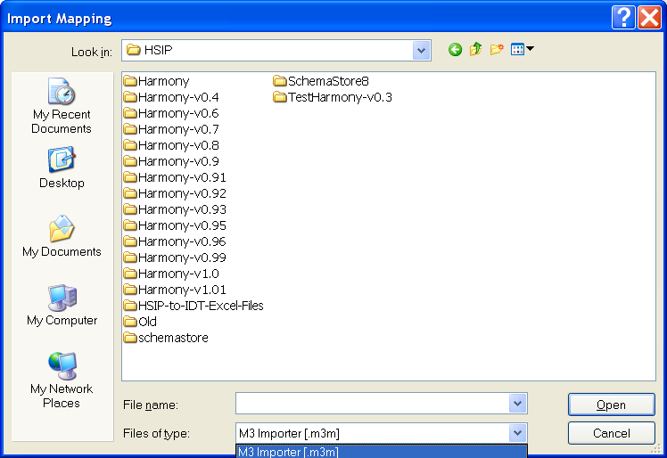
Then, navigate to the file and click “Open.” The Import Mapping file dialog will close and the Import Mapping dialog will be displayed. Click Finish to import the mapping. The main OpenII window will be visible.
To verify that the mapping was imported, click the + to the left of the word “Mappings” in the Manager pane and verify that the mapping is there:
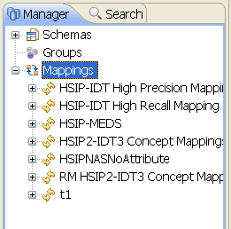
The mapping now exists within the repository and may be opened in OpenII or from within Harmony.

